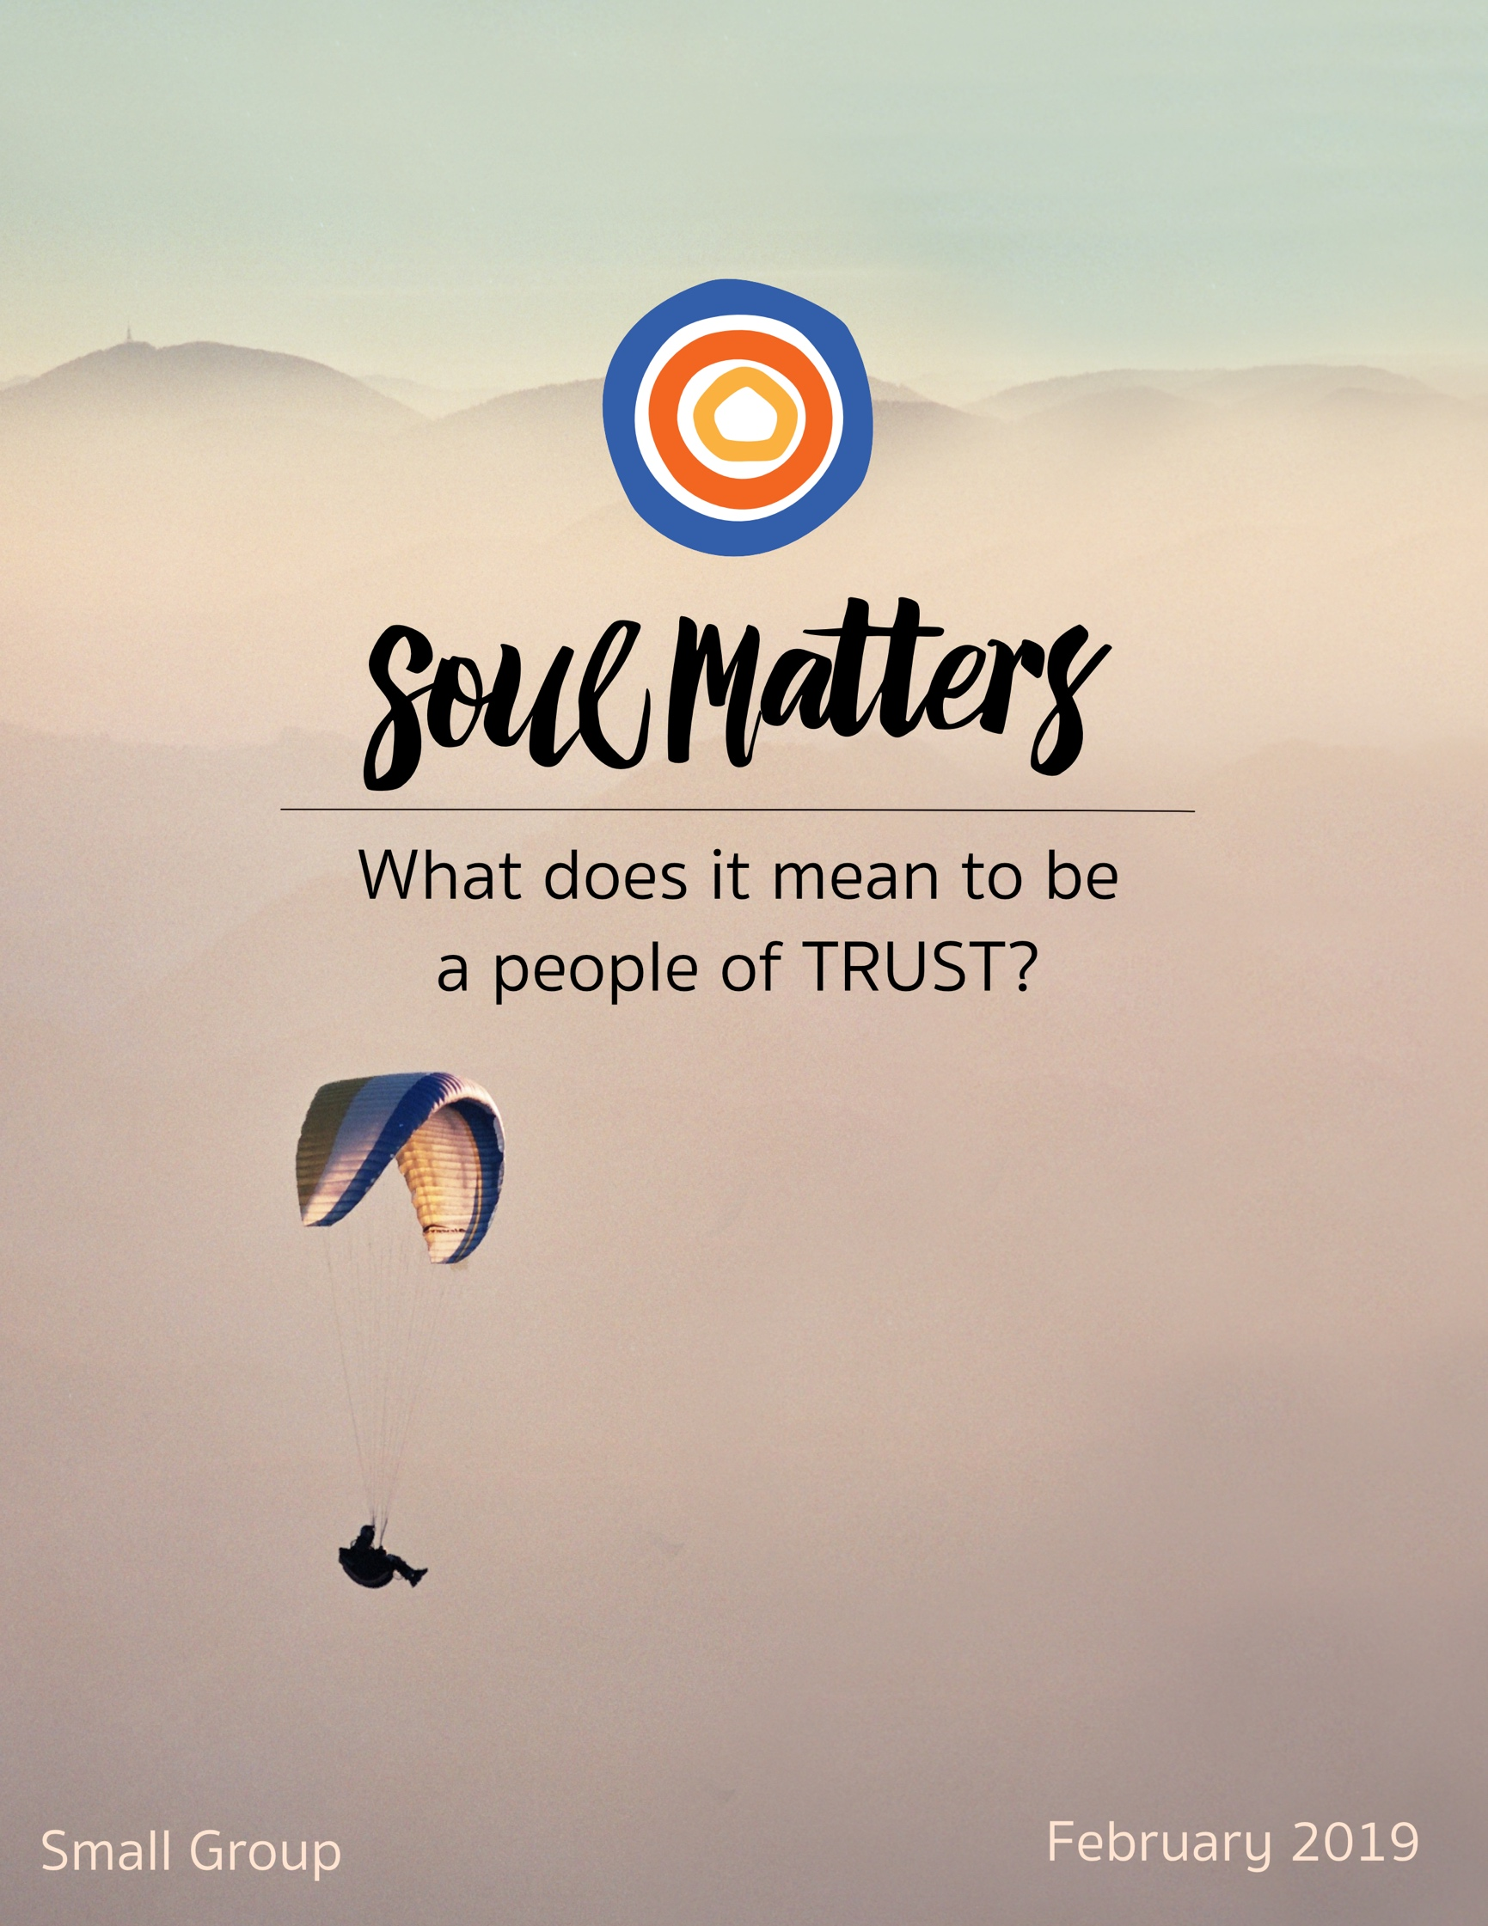

What Does It Mean To Be
A People of Trust?

In religious circles, “trust talk” most often revolves around having faith that life will look after us. For instance, our Christian friends sing hymns about God “watching over us” and keeping “an eye on the sparrow.” Our Jewish friends lift up the Exodus story to encourage faith that God will help us make our way even when things look bleak. Likewise, prayer practice for our Muslim friends is all about reminding oneself that you are in Allah’s safe hands. We UUs translate similar sentiments using the language of trusting “a Love that will not let us go.”

This call to trust Life’s support comes to us as a gift. After all, it’s all too easy to convince ourselves that life is a foe. So we need our faith communities to restore our faith that life is ultimately a friend. We need the reassurance. We need to know that when we fall we can count of being picked up.

But what about being pushed? Don’t we need to count on that too? A Love that won’t let us go is essential, but isn’t it just as important to have faith in a Love that won’t let us get too comfortable? Especially as we welcome in Black History Month, we certainly don’t want to forget about a Love that disturbs. We need a Love that promises to not let privilege remain hidden, and unsettles those who have it. A Love that tells those of us who are marginalized and tired, “I won’t let your pain be ignored.”

And just when that call to trust seems the one we all need to listen to, another voice adds itself to the mix. This one telling us to trust that it’s not all up to us. That sometimes it’s ok to rest. That doesn’t disturb but instead assures us that we can let go. That tells us to trust that we can - for a while - put the work down because others are ready to pick it up, knowing that we will be there to pick it up when rest calls to them.

So, friends, where does that leave us?
What is it?
Trust life to pick us up?
Trust life to push and poke us?
Trust that it’s ok to put the work down for a while?

It is all of them, of course. And more.

But maybe it’s mostly about trusting that we’ll know which call is right for us. Maybe it’s about having faith in ourselves and not letting anyone tell us what we need to trust.

There’s no one message this month after all. Everyone’s heart is wrestling with a loss of faith in its own way. The trust you need to repair is likely different than mine. What we both long for is safe space. Space to say how hard that work of repair is. Space to say how much it hurts to have to repair it in the first place.

So let’s remember that above all. And prove, this month, that we all can be trusted to offer each other that precious space.

Our Spiritual Exercises

Option A:

Tip Toe Toward Trusting Yourself

Facing our fears takes a whole lot of self-trust. Getting over self-doubt can seem an impossible hurdle. That’s why some advise us to simply “Jump!” “Take a leap of faith,” we’re told. “Go all in!”

But what if the secret path to overcoming our fears and believing in ourselves is not one big leap, but instead a bunch of baby steps?

This exercise is all about those baby steps. Here’s your challenge in a nutshell:

Identify one of your core fears and then find one small way of facing it.
Or to put it another way:
Find one manageable way to build your ‘I believe in myself’ muscle!

Your optoins are endless.
Fear that you’ll never get in shape? Forget getting back into the gym, just commit yourself to taking an hour long walk every Monday of this month.
Is social anxiety your nemesis? Forget forcing yourself to go to those office parties and just make yourself invite a co-worker or two out for lunch.
Fear of heights? Skip the daring sky-diving trip and simply
Terrified of public speaking? Don’t start by volunteering to do a lay sermon and instead sign up to teach an RE class.
Doubting your courage to pursue that entrepreneurial dream you’ve had for so long? Don’t quit your job and leap in. Instead simply commit to drawing up a business plan for it this month.
Been afraid to stick up for your worth at work and ask for a raise? Don’t boldly walk into your boss’ office just yet. Instead just sit down and write the raise you want on a napkin and carry it around in your pocket all month.

Bottom line: No need to jump into self-trust head first. Just tip toe toward it instead!

Option B:

Test the Trust Formula

Our monthly theme and Valentine’s Day are a perfect fit. Everyone knows that love and trust go hand in hand. But do partners build the trust needed to keep our relationships loving and strong? Psychologist and researcher, John Gottman, claims that our usual answers have it upside down. Common wisdom advises us that it’s dependable grand gestures of love that make the magic happen: surprise romantic getaways or the ability to have “deep conversations.” Gottman objects. He says, “Nope, it’s the small stuff!” Tiny things, like bringing your partner coffee or putting down your phone when they’re talking or remembering that they have a big presentation coming up next week. Gottman has even created a formula: If you average five of these small positive interactions to every one negative or failed one, you are guaranteed a loving and trust-filled relationship!

Sounds too simple, right? Well, this month, you are invited to test it out. Take some time to learn about Gottman’s theory by watching the below videos. Then commit yourself to five of these small gestures a week (or even a day!) and see what happens!

Note: It works with friendships and other relationships too! So for those of us who are single, consider testing it out with a family member or friend whose relationship you want to deepen or improve.

Videos to Watch:
- https://www.youtube.com/watch?time_continue=58&v=QHN2EKd9tuE
- https://www.youtube.com/watch?time_continue=39&v=ib7Ain2aVR0
- https://www.youtube.com/watch?time_continue=172&v=rgWnadSi91s
- https://brenebrown.com/videos/anatomy-trust-video/

A Couple Books to Dig Deeper:
- The Relationship Cure
- What Makes Love Last?: How to Build Trust and Avoid Betrayal

Option C:

A Love Letter to Life:

A Daily Reminder Why Life is Trustworthy

Our ability to trust life is related not just to what happens to us but also what we choose to focus on. So this exercise invites us to use intentional focus to strengthen our trust in life. It’s a simple but impactful practice of writing a “love letter to life” at the end of each day. Here’s a link to an article that explains the ritual and its potential:
https://www.npr.org/sections/13.7/2012/02/09/146472775/the-pulse-and-beat-of-a-daily-valentine-ritual

Try it out for a week or even two. Put your own spin on it. Come to your group ready to share your journey.

Option D:

Find the Call of Trust in Black History Month

February is Black History Month. Issues of trust are woven throughout. How does one trust in a society and systems that have repeatedly broken their promises of freedom and equality? How is trust repaired at a personal level when unacknowledged microaggressions happen over and over? How does one learn to be a trustworthy ally? The list of questions goes on and on.

And maybe the most important question is: “Which is your question?”

Black History Month contains a call for each of us. So as your spiritual exercise, make the time to explore and identify your unique call around racial justice and healing this month. How is Black History Month challenging you to deepen or repair trust? What “trust-work” is it asking of you?

To help you make your way, we’ve put together a list of various resources that address the relationship between racial justice and trust from a number of perspectives. Here’s the link to that document:

https://docs.google.com/document/d/1d9zFi5mQgpBB-Fh7gBUct91aqJovnY62rt1S3kUbmCc/edit?usp=sharing

Take your time to go through it in any way that is helpful to you. You can engage the entire list. Or just focus on the ones that stick out. Even seek out other resources if you need. The work is one of exposing yourself to the wide terrain and then finding where your trust-work is located on the map.

Option E:

Find Trust in Our Recommended Resources

Our recommended resources are full of wisdom about what it means to be a people of and a person of trust. Engaging these resources and finding the one that especially speaks to you is a spiritual practice in and of itself.

So, if none of the above exercises call to you, engage the recommended resources section of this packet as your spiritual exercise for the month.

Set aside some regular time throughout a week to go through them and meditate on them until you find the one that most expands or deepens your understanding of trust. After you’ve found it, consider printing it out and carrying it with you or pinning it up so you can continue to reflect on it throughout the weeks leading up to your group meeting. Come to your group ready to share where the journey led you.

Your Question

As always, don’t treat these questions like “homework” or try to answer every single one.
Instead, make time to meditate and reflect on the list and then pick the one question
that speaks to you most. The goal is to figure out which question is “yours.”
Which question captures the call of your inner voice? Which one contains “your work”?
What is it trying to get you to notice? Where is it trying to lead you?

- Who has taught you the most about risking trust?

- What have you trusted since childhood? What have you never lost faith in?

- How have you changed your mind about trust?

- Are you trusting or ignoring your gut right now?

- What would happen if your trusted life enough to let go?

- What would happen if you trusted that you are right where you are meant to be? That life is exactly what you need right now?

- Have you ever been surprised that someone was willing to trust you?

- When broken trust left you broken-hearted, what voice in your head or word from a friend helped you pick up the pieces?

- Have you ever felt betrayed by your country?

- What would it mean to trust people to be who they are rather than what you wish they were?

- You’re worried about how this thing in front of you is going to work out. Might it be possible to trust that you will be fine either way?

- What have you learned about trusting grief, rather than trying to make it go away?

- Has it ever been hard to trust that your children will find their way?

- What’s your question? Your question may not be listed above. As always, if the above questions don't include what life is asking from you, spend the month listening to your days to hear it. Or maybe the question or call you need to hear is waiting in one of the quotes listed below. Consider looking there!

Companion Pieces

Recommended Resources for Personal Exploration & Reflection

The following resources are not required reading. We will not analyze these pieces in our group. Instead they are here to companion you on your journey this month, get your thinking started and open you to new ways of thinking about what it means to be part of a people of trust.

Word Roots

“Trust comes from the Norse traust, Proto-Germanic traustam, and Old English treowian. All these roots point to confidence, reliance, protection, solace, and support. They ask, where do you find your confidence? Where do you find solace?” - source

“I was noticing that trust and truth share the first three letters “tru”. I went searching for the origins and etymology of both words, trust and truth, and found that they share in common one word — faithful. I began to explore then how trust and truth might be linked and to what and whom is it that I am faithful.” - source

Wise Words

As you start to walk out on the way, the way appears.
Rumi

I imagine trust as these invisible hands that we stretch out into the world looking for someone to hold on to as we walk into the unknown future.”
Alya Titarenko

To have faith is to trust yourself to the water. When you swim you don’t grab hold of the water, because if you do you will sink and drown. Instead you relax, and float
Alan Watts

In our prayers, we are “nestling in” with reality, adopting a stance that declares we trust what is “out there” and what is “inside.” In moments of meditation we assume a certain confidence, a faith that what is, is ultimately friendly, capable of supporting our life… No matter what befalls, no matter what you become, Love awaits…
Barbara Merritt
As free congregations we enter into this covenant, promising to one another our mutual trust and support.
Closing affirmation to our Unitarian Universalist Statement of Principles

Distance doesn’t ruin a relationship, doubts do.
Unknown

When something feels off; it is. Trust Yourself.
Unknown

A bird sitting on a tree is never afraid of the branch breaking, because her trust is not in the branch but in her own wings.
Unknown

Today I want to greet joy
Without a trace of suspicion.
Amy Loyd

Few delights can equal the mere presence of one whom we trust utterly.
George MacDonald

It is mutual trust, even more than mutual interest that holds human associations together.
H.L. Mencken

Trust is like the air we breathe. When it’s present, nobody really notices. But when it’s absent, everybody notices.
Warren Buffett

When you’re surrounded by all these people, it can be even lonelier than when you’re by yourself. You can be in a huge crowd, but if you don’t feel like you can trust anybody or talk to anybody, you feel like you’re really alone.
Fiona Apple

You may be deceived if you trust too much, but you will live in torment if you don’t trust enough.
Frank Crane

The only way you can make a [person] trustworthy is to trust [them].
Henry Stimson

I don't need a certain number of friends, just a number of friends I can be certain of.
Alice Walker

The glory of friendship is not the outstretched hand, not the kindly smile, not the joy of companionship; it is the spiritual inspiration that comes to one when you discover that someone else believes in you and is willing to trust you with a friendship.
Ralph Waldo Emerson

Crocodiles are easy. They try to kill and eat you. People are harder. Sometimes they pretend to be your friend first.
Steve Irwin, famed wild animal trainer

I’ve come to trust not that events will always unfold exactly as I want, but that I will be fine either way.
Marianne Williamson

Follow your bliss and the universe will open doors for you where there were only walls.
Joseph Campbell

There is always that edge of doubt. Trust it. That's where the new things come from.
Albert Huffstickler

If you can trust yourself when all men doubt you,
But make allowance for their doubting too…
Yours is the Earth and everything that’s in it…
Rudyard Kipling, from “If”

Trust that truth whether good or bad, pretty or ugly, is still truth . . . the knowledge of anything true brings freedom and empowerment back to oneself.
Alice Walker
You were born with greatness.
You were born with wings.
You are not meant for crawling,
so don’t.
You have wings.
Learn to use them and fly.
Rumi, on trusting yourself

You have brains in your head.
You have feet in your shoes.
You can steer yourself any direction you choose.
You’re on your own.
And you know what you know.
And YOU are the one
who’ll decide where to go…
Dr. Seuss, on trusting yourself

Trusting Grief
John O'Donohue
Full poem at http://www.ayearofbeinghere.com/2015/12/john-odonohue-for-grief.html
When you lose someone you love...
It becomes hard to trust yourself.
All you can depend on now is that
Sorrow will remain faithful to itself.
More than you, it knows its way…

Blessing for the Brokenhearted (A heart that trusts its own beating)
Jan Richardson, From The Cure for Sorrow: A Book of Blessings for Times of Grief
Full poem found at http://paintedprayerbook.com/2014/02/10/a-blessing-for-the-brokenhearted/

Let us agree
for now
that we will not say
the breaking
makes us stronger
or that it is better
to have this pain
than to have done
without this love…
Perhaps for now
it can be enough
to simply marvel
at the mystery
of how a heart
so broken
can go on beating,

as if it were made
for precisely this…
as if it trusts
that its own
persistent pulse
is the rhythm
of a blessing
we cannot
begin to fathom
but will save us
nonetheless.

Wait (Trusting Time)
Galway Kinnell
Full poem at http://www.ayearofbeinghere.com/2014/10/galway-kinnell-wait.html
Wait, for now.
Distrust everything, if you have to.
But trust the hours. Haven't they
carried you everywhere, up to now?

Songs and Music

I Believe In You (Don Williams)
Cover by Carli Tuttle
https://www.youtube.com/watch?v=T3rOirfCjA4

Escape
AHI
https://www.youtube.com/watch?v=ehnyzsuVHAc

I Believe in the Sun
Mark A. Miller
https://www.youtube.com/watch?v=mk7EX9Rdpwk

I Will Be Your Standing Stone
MUSE Choir
https://www.youtube.com/watch?v=YminLnyYU5w
https://www.youtube.com/watch?v=wpMW8-Nx4T0
Not just a song. Watch the creation of a meditation on the trustworthiness of friendship.

More “Trust Songs” are found on our February Soul Matters Spotify playlist. Click here to check them out! You can also explore the playlists from other months here.
Online & Videos

The Anatomy of Trust
Brené Brown
https://brenebrown.com/videos/anatomy-trust-video/
Trust is built in the small moments not the grand gestures!

Why Trust Is Worth It
https://www.youtube.com/watch?v=cWypWe9UAhQ
A spoken and movement meditation on trust. In Collaboration with Cirque Du Soleil.

Why Should We Trust Scientists
Naomi Oreskes
https://www.ted.com/talks/naomi_oreskes_why_we_should_believe_in_science
Historian of science Naomi Oreskes thinks deeply about our relationship to belief and draws out three problems with common distrustful attitudes toward scientific inquiry -- and gives her own reasoning for why we ought to trust science. [spoiler alert: her answer is not what you might expect!]

Rethinking Infidelity
https://www.ted.com/talks/esther_perel_rethinking_infidelity_a_talk_for_anyone_who_has_ever_loved#t-370974

Deception - Radiolab Podcast
https://www.wnycstudios.org/story/91612-deception
Explores the flipside of trust and asks whether it is possible for anyone to lead a life without deception. How are we to understand the strange power of lying to yourself and others?

A Founding Contradiction: Thomas Jefferson's Stance On Slavery
Hidden Brain Podcast
https://www.npr.org/2018/11/26/670803601/a-founding-contradiction-thomas-jeffersons-stance-on-slavery
On what it means to tell a trustworthy and full version of our history and how such tellings call us to more trustworthy and true tales of our own contradictions.

How to Deal with the Police - Parents Explain
Cut Video
https://www.youtube.com/watch?v=coryt8IZ-DE

Can Black Lives Matter & Law Enforcement See Eye To Eye?
Middle Ground Videos
https://www.youtube.com/watch?v=S6rDvbQ-mz4

Articles

Being Brave Is Stepping Backward and Trusting Our Children - On Being
https://onbeing.org/blog/being-brave-is-stepping-backward-and-trusting-our-children/
“As parents, we spend a lot of time worrying about our children. We fret about the degree to which our parenting affects their development and well-being. Yet children are actually emancipated individuals who would spare us the insecurities of raising them, if we would trust them…”

The Science of Trust: Economics and Virtue
Paul Zak
https://onbeing.org/programs/paul-zak-the-science-of-trust-economics-and-virtue/
“We've culturally moved from seeing Wall Street as an icon of thriving civil society to discussing its workings with book titles like House of Cards and Animal Spirits. As part of our ongoing Repossessing Virtue series, we look at what science is learning about trust, fair play, and empathy…”
Excerpt: “I discovered that trust was sort of the big gun economists have been looking for. It's really the most powerful lever we've found to date to understand why countries are rich or poor...”

Restoring Social Trust is Essential
David Brooks
https://www.timesunion.com/opinion/article/David-Brooks-Restoring-social-trust-is-essential-12988950.php
“What you see then is not merely a disagreement about trade or this or that, but two radically different modes of politics, which you might call high-trust politics versus low-trust politics…”
Can You Trust Your Gut?
Eric Barker
https://www.bakadesuyo.com/2013/01/malcolm-gladwell-accurate-judgments-blink/

The Ten Best Ways to Build Trust
Eric Barker
https://www.bakadesuyo.com/2013/07/build-trust-in-a-relationship/

Building Trust Works in the Opposite Way that You Think
Adam Grant & Daniel Coyle
https://qz.com/work/1241911/daniel-coyle-author-of-the-the-culture-code-says-building-trust-works-in-the-opposite-way-you-think-it-does/
“I had it backward. I always thought, ‘Once we trust each other, then I can go out on a limb, because I don’t have to worry about you harming me or taking advantage of me or letting me down.’ You said, ‘Actually, you take risks together first, and that’s how you build trust.’”

Black History Month & Trust

The Healing Is Not Done
Rebekah Savage
https://www.uua.org/worship/words/homily/promise-and-practice-healing-not-done-reflection
“I play this moment over and over again in my head: the day I heard of the Thomas Jefferson Ball, hosted by Unitarian Universalists in 1993… I grieve for the hurts that this time in our history caused. I grieve for those who left our communities because of how this event was handled, which broke their trust in finding spacious rest in our congregations from the pervasive, violent racism in our country…”

The UU Empowerment Tragedy - UU World
Rev. Mark Morrison-Reed
https://www.uuworld.org/articles/empowerment-tragedy
“Four decades have passed since controversy over ‘black empowerment’ nearly tore the Unitarian Universalist Association apart. Even now, UUs remain unreconciled over what was for many a life-defining fight.”

History and Ministry of Black Lives of Unitarian Universalism
https://www.uua.org/giving/areas-support/funds/promise-and-practice/history-black-lives-uu

For Our White Friends Desiring to Be Allies
https://sojo.net/articles/our-white-friends-desiring-be-allies?fbclid=IwAR2fcZQDZScoMHEOTKPYEoycqF7CVivlBovzBL09sd_q8-KkZo40LtIgEyo
On how to be trusted as an ally.

On “Let America Be America Again” by Langston Hughes
Camille Rankine
https://www.poets.org/poetsorg/12-poems-read-black-history-month
Scroll down to Langston’s Hughes poem and the reflection is underneath
“Let America Be America Again” has been ringing in my ears for months now. It snaked its way into the back of my mind when the Trump campaign rolled out its red-hatted slogan: “Make America Great Again.” The first time I saw those words, I knew exactly what they meant, and that they weren’t meant for me…”

Books

Tears We Cannot Stop: A Sermon to White America
Michael Eric Dyson
https://www.uuabookstore.org/Tears-We-Cannot-Stop-P18180.aspx
On facing the fact that trust has been broken: “Short, emotional, literary, powerful-Tears We Cannot Stop is the book that all Americans who care about the current and long-burning crisis in race relations will want to read… Dyson argues that if we are to make real racial progress we must face difficult truths, including being honest about how black grievance has been ignored, dismissed, or discounted.”
Mindful of Race
Ruth King
https://ruthking.net/mindful-of-race/
On race and rebuilding trust from the perspective of mindfulness and meditation.

The Invisible Gorilla: How Our Intuitions Deceive Us
Christopher Chabris
https://www.amazon.com/gp/product/0307459667/ref=as_li_ss_tl?tag=spacforrent-20&ie=UTF8
On being able to trust ourselves

The Science of Trust: Emotional Attunement for Couples
John M. Gottman
https://www.amazon.com/Science-Trust-Emotional-Attunement-Couples-ebook/dp/B005459RHI
Article about the book: https://www.psychologytoday.com/us/blog/the-older-dad/201303/do-i-trust-you-anymore

Movies

Ten Must Watch Black History Documentaries
http://www.pbs.org/black-culture/explore/10-black-history-documentaries-to-watch/?fbclid=IwAR24Avh-xXWFDOkaEAPmS0rjwLWGaQ7gIE40cUV5T_0B5tSoTt2EWRxvlmo#.W_oNBy3Mz8o

Moonrise Kingdom
On the trustworthy friendships that see us through the storm

The Informant!
Spotlight
Thank You for Smoking
Shattered Glass
Movies on social and corporate trust

How To Train Your Dragon
Family film on friendship and trust

Iron Giant
Family film about fear and trust of the unknown

Get Daily Inspiration
on the monthly theme by liking our
Soul Matters Facebook inspiration page:
https://www.facebook.com/soulmatterssharingcircle/

Find Musical Inspiration
on each theme by following our monthly
Spotify lists:
https://www.soulmatterssharingcircle.com/spotify-lists.html

Explore the Theme with Your Family
by getting our monthly parent guides,
Soulful Home:
https://www.soulmatterssharingcircle.com/soulful-home.html

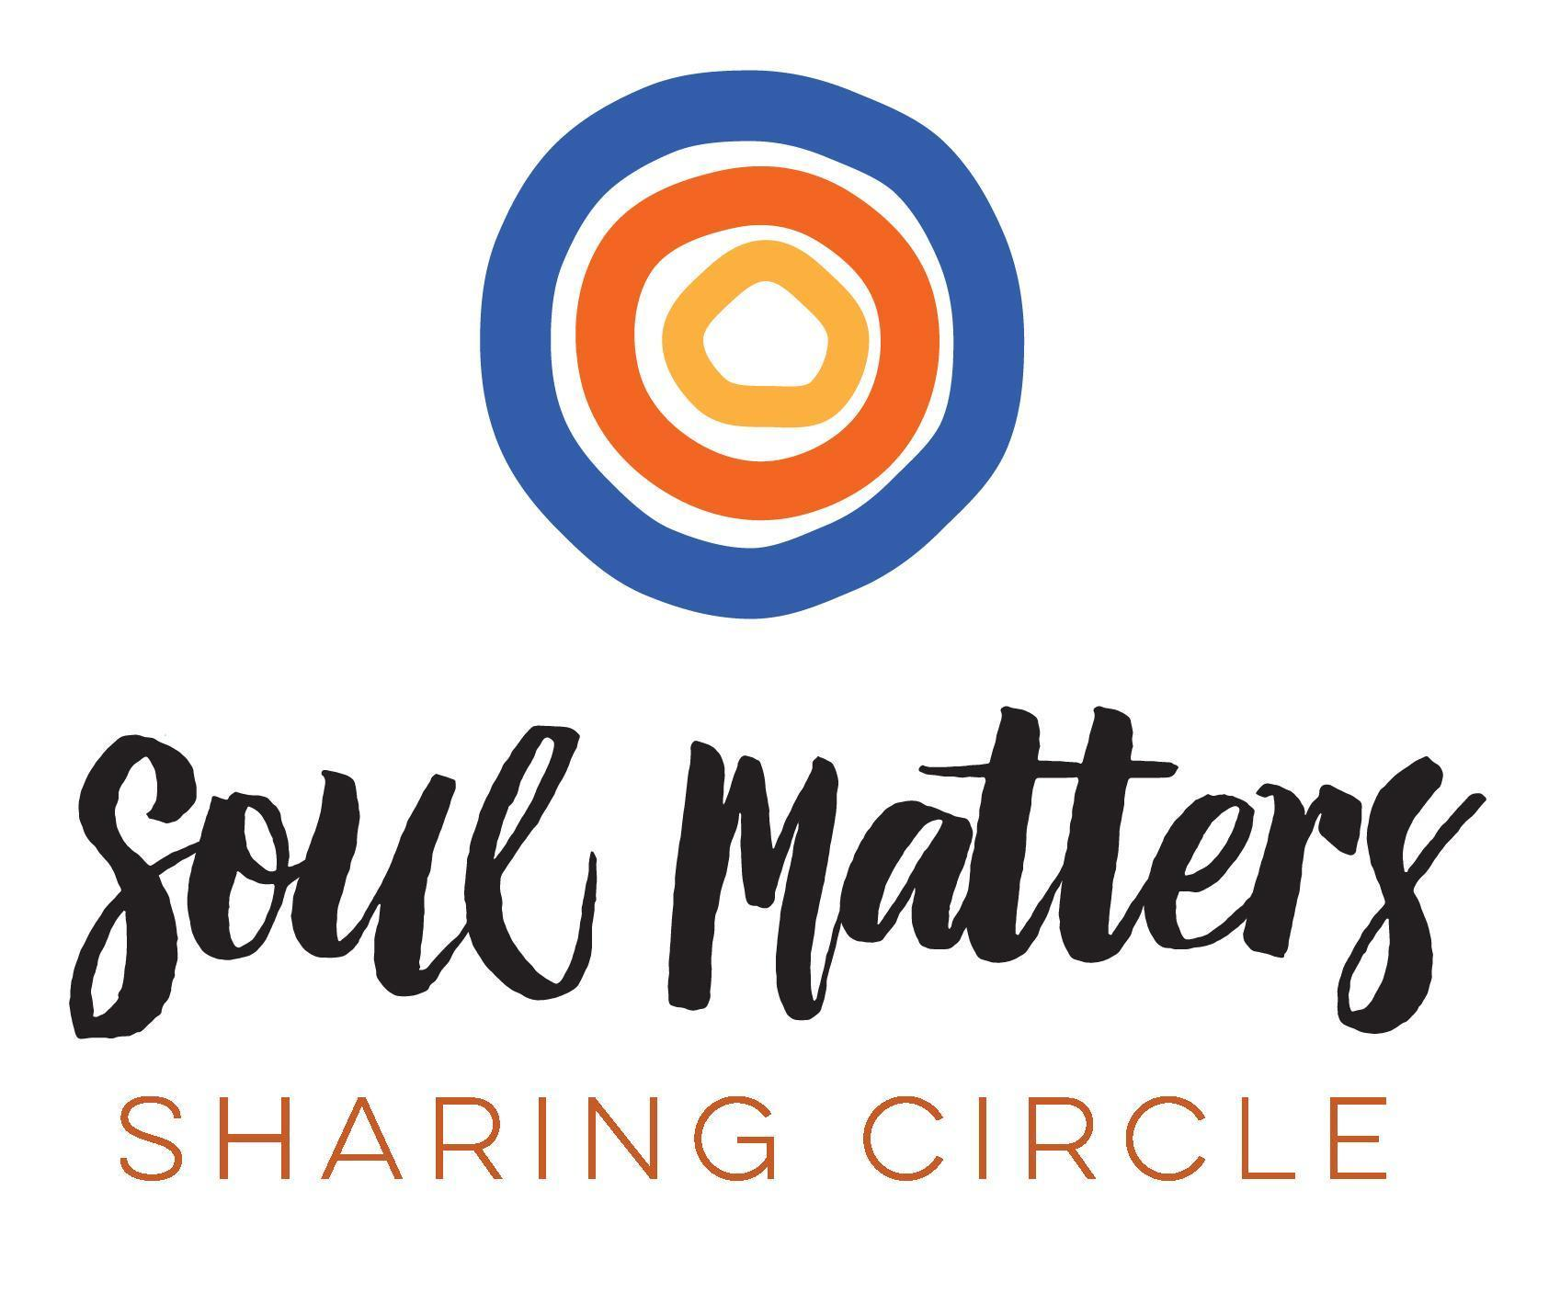
© 2018-19 Soul Matters ALL RIGHTS RESERVED

Packets are for use ONLY by member congregations of the Soul Matters Sharing Circle.
Learn how to join athttp://www.soulmatterssharingcircle.com

